# Brainstorm

**TIP**

You can select a sticky note and hit the pencil [switch to sketch] icon to start drawing!

#### Before you collaborate

A little bit of preparation goes a long way with this session. Here’s what you need to do to get going.

**10 minutes**

**1**

#### Define your problem statement

What problem are you trying to solve? Frame your problem as a How Might We statement. This will be the focus of your brainstorm.

**5 minutes**

**2**

#### Brainstorm

Write down any ideas that come to mind that address your problem statement.

**10 minutes**

**3**

#### Group ideas

Take turns sharing your ideas while clustering similar or related notes as you go. In the last 10 minutes, give each cluster a sentence-like label. If a cluster is bigger than six sticky notes, try and see if you and break it up into smaller sub-groups.

**20 minutes**

**4**

#### Prioritize

Your team should all be on the same page about what's important moving forward. Place your ideas on this grid to determine which ideas are important and which are feasible.

**20 minutes**

#### After you collaborate

You can export the mural as an image or pdf to share with members of your company who might find it helpful.

**Quick add-ons**

# & idea prioritization

**PROBLEM**

**How might we [your problem statement]?**

### Use this template in your own brainstorming sessions so your team can unleash their imagination and start shaping concepts even if you're not sitting in the same room.

1. **Team gathering**

Define who should participate in the session and send an invite. Share relevant information or pre-work ahead.

1. **Set the goal**

Think about the problem you'll be focusing on solving in the brainstorming session.

1. **Learn how to use the facilitation tools**

Use the Facilitation Superpowers to run a happy and productive session.

Problems faced:

**TIP**

Add customizable tags to sticky notes to make it easier to find, browse, organize, and categorize important ideas as themes within your mural.

Damage of crops by animals

Damage by climatic conditions

Crop diseases

**SENTHILKUMAR.S**

Use of drones

detection of soil moisture

**SHATHIKA.B**

## 

Sensors to detect crop diseases

Crop growth monitored

### Climatic conditions monitored

Alarm to scare animals

ors for ecting imals

sens det an

less

asonic

Ultr

Using traditional pesticide spraying method which can be deployed as one part

1. **Share the mural**

**Share a view link** to the mural with stakeholders to keep them in the loop about the outcomes of the session.

1. **Export the mural**

Export a copy of the mural as a PNG or PDF to attach to emails, include in slides, or save in your drive.

Drone mechanisms can be applied for aerial supervision

**10 minutes** to prepare

**1 hour** to collaborate

**2-8 people** recommended

[**Open article**](https://support.mural.co/en/articles/2113740-facilitation-superpowers)

PIR sensors can be used

Wireless sensors used

Alarm to scare the animals

Ultrasonic sensors used to detect animal movement

#### Key rules of brainstorming

To run an smooth and productive session

**SINEKA.A**

Monitoring through drones

High frequency to kill pests

**AKASH.G**

Face recognition done

Smart fences used

### sensors used

Wire

#### Keep moving forward

**Strategy blueprint**

Define the components of a new idea or strategy.

[**Open the template**](https://app.mural.co/template/e95f612a-f72a-4772-bc48-545aaa04e0c9/984865a6-0a96-4472-a48d-47639307b3ca)

**Customer experience journey map**

Stay in topic. Defer judgment.

Encourage wild ideas. Listen to others.

#### Importance

Solar energy can be harnessed to operate our prototype so that it can pave way to conventionalization

If each of these

Understand customer needs, motivations, and obstacles for an experience.

[**Open the template**](https://app.mural.co/template/b7114010-3a67-4d63-a51d-6f2cedc9633f/c1b465ab-57af-4624-8faf-ebb312edc0eb)

Go for volume. If possible, be visual.

tasks could get

done without any difficulty or cost, which would have the most positive impact?

**Strengths, weaknesses, opportunities & threats**

Identify strengths, weaknesses, opportunities, and threats (SWOT) to develop a plan.

|  |  |
| --- | --- |
|  |  |
|  |  |

[**Open the template**](https://app.mural.co/template/6a062671-89ee-4b76-9409-2603d8b098be/ca270343-1d54-4952-9d8c-fbc303ffd0f2)

Traditional spraying of pesticides are utilized so that they can be sprayed to all the crops in uniform pattern thereby enhancing protection

### Smart fences used

Irrigation control

Destroying weeds

Smart Scarecrow used

Climatic conditions monitored

[**Share template feedback**](https://muralco.typeform.com/to/CiqaHVat?typeform-source=app.mural.co)

Sensors to

Using solar energy is a best replacement for electrical energy which is difficult to be accessed in village areas. And also it is cost effective, scalabe , long lasting charge.

Drones are highly prefered in this project mainly for their easy accessibility via air medium. Using flying mechanisms , drones can be taken to fly through the crops with high scale of detection for pests

**TIP**

Participants can use their cursors to point at where sticky notes should go on the grid. The facilitator can confirm the spot by using the laser pointer holding the **H key** on the keyboard.

monitor crop disease

[**Share template feedback**](https://muralco.typeform.com/to/CiqaHVat?typeform-source=app.mural.co)

#### Feasibility

Regardless of their importance, which tasks are more feasible than others? (Cost, time, effort, complexity, etc.)

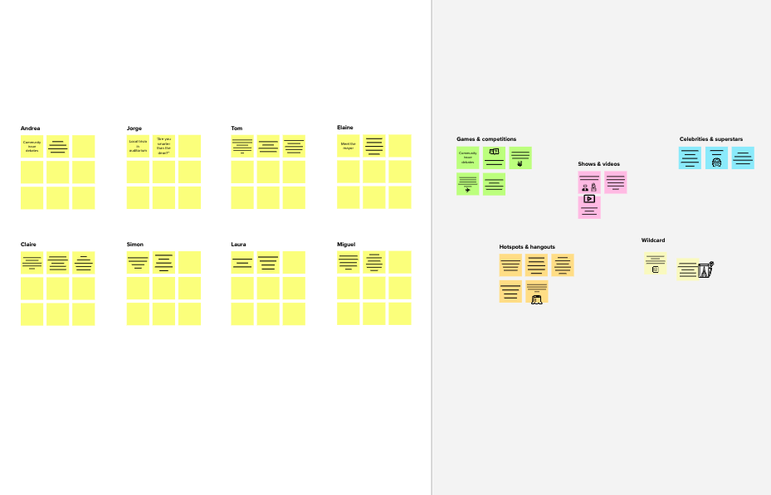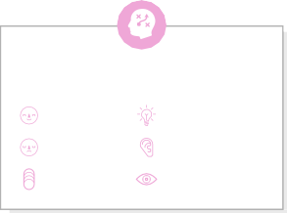

**Template**

**Need some inspiration?**

See a finished version of this template to kickstart your work.

[**Open example**](https://app.mural.co/template/e5a93b7b-49f2-48c9-afd7-a635d860eba6/93f1b98d-b2d2-4695-8e85-7e9c0d2fd9b9)